SIMATS ENGINEERING
ASSESSMENT TOOL 3

COURSE NAME: Artificial Intelligence COURSE CODE: CSA17

COURSE OUTCOME COVERED

CO5: Design AI-based systems using PySpark, RDD operations, and intelligent agent architectures, using scalable systems and integrate components in distributed AI applications. (BTL 5)

Assessment Tool Weightage: 20%

Duration : 1 Hour
QUESTIONS: 5 Total Marks:50

Annexure A

Reverse Engineering

Code of Conduct:

I ____________________ (Name / Reg No) certify that this submission is my original work and that I have adhered
to the guidelines specified for this assessment.
I understand that any violation of academic integrity rules will result in disciplinary action.

Signature of the student:

Annexure A
Reverse Engineering

1. System Decomposition & Analysis
Analyze an existing AI-based system and reverse engineer its architecture, identifying key components, data flow, and underlying algorithms.

2. Architecture Reconstruction
Given a black-box software system, reconstruct its system architecture and explain the interaction between modules using appropriate diagrams.

3. Algorithm Identification
Reverse engineer a machine learning application to identify the algorithms, data processing steps, and decision-making logic used in the system.

4. Data Flow & Process Mapping
Examine an existing distributed AI application and map its data flow, processing pipeline, and communication between components.

5. Improvement & Redesign
Perform reverse engineering on an intelligent system and propose enhancements or redesign strategies to improve scalability, efficiency, and performance.

RUBRICS FOR CALCULATION

Criteria | Weightage | Level 4 – Exemplary | Level 3 – Proficient | Level 2 – Developing | Level 1 – Beginning
Understanding of Industry Problem | 20% | Comprehensive understanding of real-world problem and constraints | Good understanding with minor gaps in requirements | Basic understanding; some requirements unclear | Poor understanding; misinterprets problem context
Application of Engineering Concepts | 25% | Applies advanced and relevant concepts effectively to solve the problem | Applies appropriate concepts with minor errors | Limited application of concepts | Incorrect or no application of concepts
Solution Design | 25% | Innovative, practical, and feasible solution aligned with industry standards | Logical and feasible solution with minor gaps | Basic solution with limited feasibility | Unclear or impractical solution
Use of Tools | 15% | Effective use of modern tools, technologies, and real data | Appropriate use of tools with correct implementation | Limited or inconsistent use of tools | Minimal or incorrect use of tools
Analysis | 10% | Thorough analysis with validated results and performance evaluation | Good analysis with reasonable validation | Basic analysis with limited validation | Poor or no analysis
Professionalism | 5% | Highly professional, well-documented, and clearly presented work | Good documentation and presentation | Basic documentation with some gaps | Poor documentation and presentation

CO5 – AT3 - REVERSE ENGINEERING SOLUTION DOCUMENT
AI-Based Intelligent Examination Seating Allocation and Optimization System

NAME: Harish S
REG.NO: 192511119
COURSE CODE/NAME: CSA1717 – ARTIFICIAL INTELLIGENCE

Attribute | Detail
Domain | Artificial Intelligence
Sub-Domain | AI-based Optimization and Intelligent Scheduling
Application Domain | Educational Technology / Examination Management
Analysis Type | Reverse Engineering Analysis of the Proposed System
Algorithms Analyzed | Greedy Algorithm, CSP with Backtracking, Hill Climbing
Document Type | Academic Capstone Submission

Note: This document analyzes the proposed system defined in the project specification as if it were an existing (black-box) system, in order to satisfy the reverse-engineering component of the capstone submission.

Table of Contents
0. Purpose and Scope of the Reverse Engineering Analysis
1. System Decomposition and Analysis
2. Architecture Reconstruction
3. Algorithm Identification
4. Data Flow and Process Mapping
5. Improvement and Redesign
6. Conclusion
Note: Section and page numbers will refresh automatically to match final pagination when opened in Microsoft Word (right-click → Update Field), or can be regenerated as a live Table of Contents if required for submission.

0. Purpose and Scope of the Reverse Engineering Analysis
This document presents a reverse-engineering analysis of the AI-Based Intelligent Examination Seating Allocation and Optimization System described in the accompanying project specification and solution document. Reverse engineering, in the context of this capstone submission, refers to the systematic process of examining the proposed system's design, structure, algorithms, and data flow in order to understand how it is built and to identify opportunities for improvement, exactly as would be done when analyzing an already-deployed intelligent system.
Because this is a capstone project rather than a pre-existing commercial product, the system is treated as a fully specified "white-box-to-black-box" candidate: its architecture, modules, algorithms and database schema are already known from the design specification, and this document re-derives that same understanding using the standard reverse-engineering lens requested for academic evaluation — decomposition, architecture reconstruction, algorithm identification, data-flow mapping, and improvement/redesign. No technologies, datasets, algorithms or performance values beyond those defined in the original specification have been introduced.
The analysis is organized into five parts, corresponding to the five reverse-engineering activities required for this submission:
- System Decomposition and Analysis
- Architecture Reconstruction
- Algorithm Identification
- Data Flow and Process Mapping
- Improvement and Redesign

1. System Decomposition and Analysis
Objective: Analyze the AI-based examination seating allocation system and reverse engineer its architecture, identifying key components, data flow, and underlying algorithms.

1.1 Approach to Decomposition
The system is decomposed from the outside in, the way an analyst would approach an unfamiliar deployed application: first by observing the user-facing functionality (the pages and actions available to the administrator), then by inferring the services that must exist behind those pages, then by identifying the persistent data structures those services depend on, and finally by isolating the computational core — the seating-allocation algorithms — that produces the system's primary output.

1.2 Component Inventory
The following components were identified as the constituent parts of the system:
Component | Type | Primary Responsibility
React Frontend (Presentation) | Client Application | Renders login, dashboard, and CRUD/allocation/report screens; sends requests to the API layer
FastAPI Backend (Application/API) | Server Application | Exposes REST endpoints, performs authentication, validation, and orchestrates algorithm execution
AI Processing Layer | Computational Module | Executes Greedy, CSP + Backtracking, and Hill Climbing seating algorithms and validates constraints
SQLite Database (Data Layer) | Persistent Storage | Stores Admin, Department, Student, Room, Subject, Examination, Seat Allocation, Algorithm Result and Performance Metric records
Authentication Subsystem | Cross-Cutting Service | Issues and validates JWT tokens and manages password hashing for administrator login
Report Generation Subsystem | Utility Service | Produces PDF and Excel reports for seating, room allocation, and algorithm performance
Performance Measurement Subsystem | Instrumentation Module | Captures execution time, room utilization, constraint satisfaction rate, conflict count, and memory usage for each algorithm run

1.3 Responsibilities and Interfaces
Each component exposes a narrow interface to the rest of the system, which is consistent with a layered design rather than a monolithic one:
- The React Frontend never accesses the database directly; it communicates exclusively through Axios calls to the FastAPI REST API.
- The FastAPI Backend never implements seating logic itself; it delegates seat generation to the AI Processing Layer and persists the result through SQLAlchemy models.
- The AI Processing Layer is stateless between invocations: it receives student, room and constraint data as input and returns a candidate seating arrangement plus performance metrics, without maintaining its own storage.
- The Data Layer (SQLite) is the single source of truth for all entities and is accessed only through SQLAlchemy ORM models and Pydantic schemas, which enforce data validation before persistence.

1.4 Underlying Algorithms Identified
Decomposition of the AI Processing Layer reveals three distinct, independently invocable algorithms, each operating on the same problem representation (students, rooms, seats and constraints) but using a different search/optimization strategy:
Algorithm | Strategy Class | Role in the System
Greedy Algorithm | Constructive heuristic | Produces a fast, locally-optimal initial seating arrangement
CSP with Backtracking | Exhaustive constraint search | Produces a systematically constraint-valid seating arrangement
Hill Climbing | Local-search metaheuristic | Iteratively improves an existing valid seating arrangement

A full explanation of each algorithm's internal decision logic is provided in Section 3 (Algorithm Identification).

1.5 Decomposition Summary Diagram

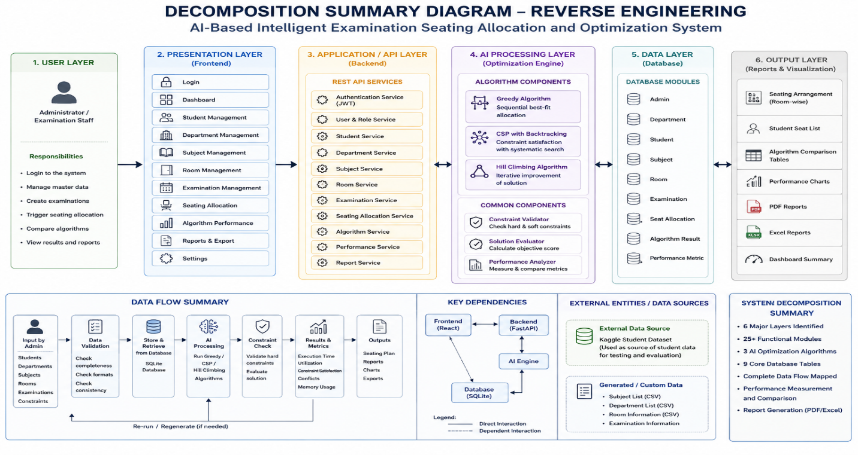
Figure 1.1 — Component decomposition of the examination seating system

2. Architecture Reconstruction
Objective: Given the specified system, reconstruct its system architecture and explain the interaction between modules using appropriate diagrams, as would be done for a black-box software system under analysis.

2.1 Reconstructed Layered Architecture
Observing the module inventory and the endpoints each module must expose, the system architecture reconstructs cleanly into four layers, consistent with a standard layered full-stack AI application:
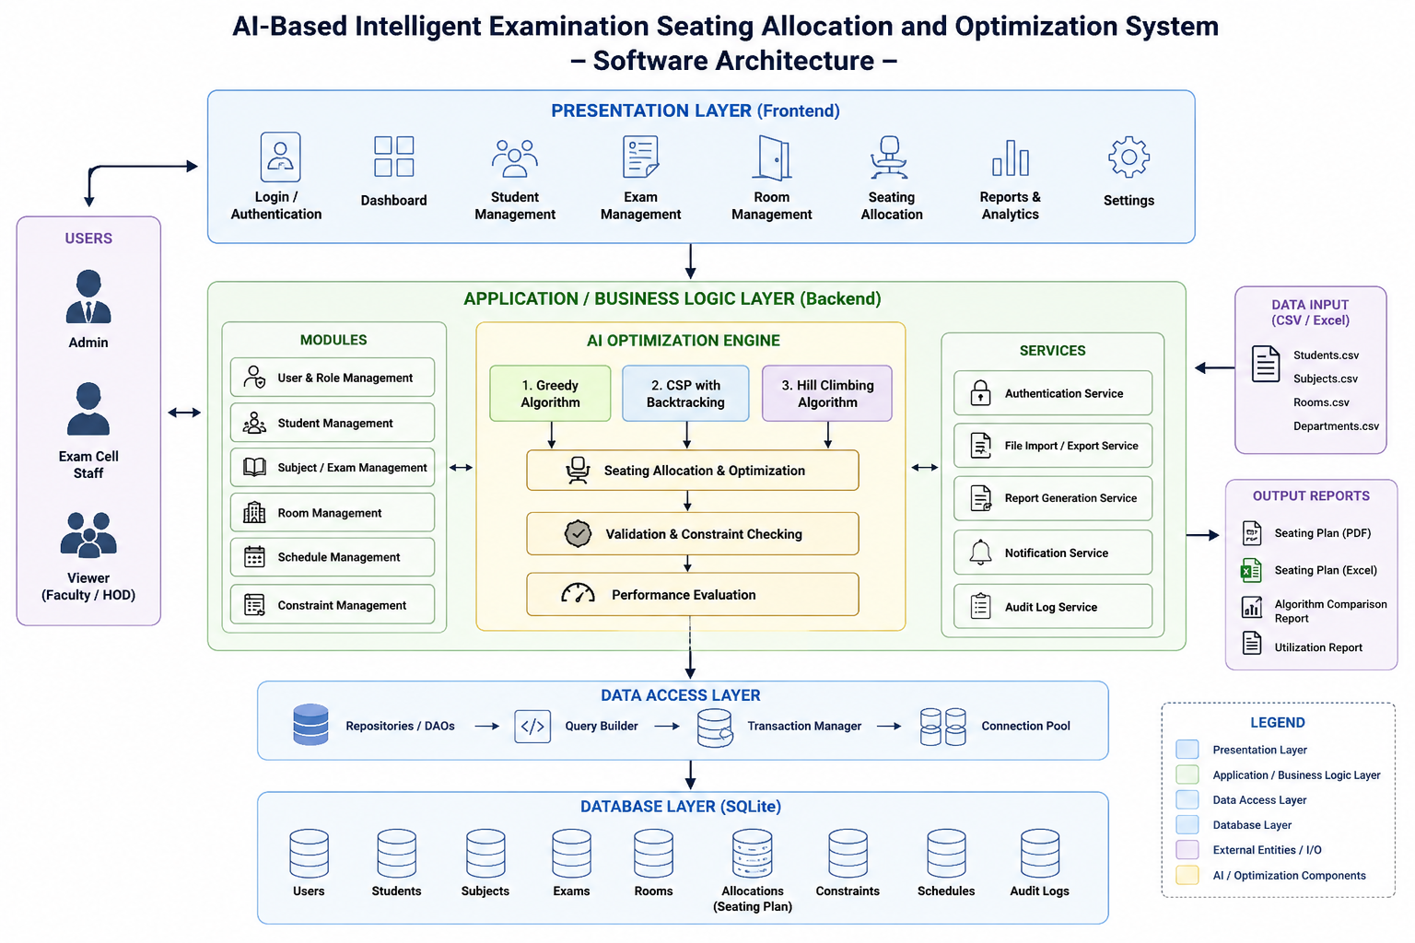
Figure 2.1 — Reconstructed layered architecture

2.2 Module Interaction Analysis
Interaction between modules was reconstructed by tracing what data each module must send and receive in order for the system's specified functional modules (Data & Examination Management, AI-Based Seating Allocation, Performance Analysis & Reporting) to work:
Source Module | Target Module | Interaction / Payload
Login Page | Auth Subsystem (API) | Credentials -> JWT token
Student/Department/Subject/Room/Examination Pages | CRUD Endpoints (API) | Create/Read/Update/Delete requests -> entity records
Seating Allocation Page | Allocation Endpoint (API) | Examination ID + selected rooms + selected algorithm -> seating arrangement
Allocation Endpoint (API) | AI Processing Layer | Student list + room list + constraints -> candidate arrangement + metrics
AI Processing Layer | Data Layer | Read: student/room/examination data. Write: Seat_Allocation, Algorithm_Result, Performance_Metric
Performance Comparison Page | Performance Endpoint (API) | Examination ID -> algorithm comparison table + chart data
Reports Page | Report Endpoint (API) | Report type + examination ID -> PDF/Excel file

2.3 Black-Box to White-Box Reconstruction Notes
Treating the system as a black box that only exposes its React user interface, an analyst could reconstruct the presence of the underlying API and AI layers purely from observable behavior:
- Multiple distinct algorithm results for the same examination (visible on the Performance Comparison screen) imply that seat generation is not a single fixed function but a selectable strategy — evidence of the three-algorithm AI Processing Layer.
- The ability to regenerate a seating arrangement without re-entering student data implies server-side persistence — evidence of the Data Layer and its Student/Room/Examination tables.
- Protected routes that redirect to a login screen when unauthenticated imply a token-based authentication subsystem — evidence of JWT usage.
- Downloadable PDF and Excel outputs imply a dedicated report-generation service distinct from the main CRUD API.

2.4 Deployment / Component Diagram

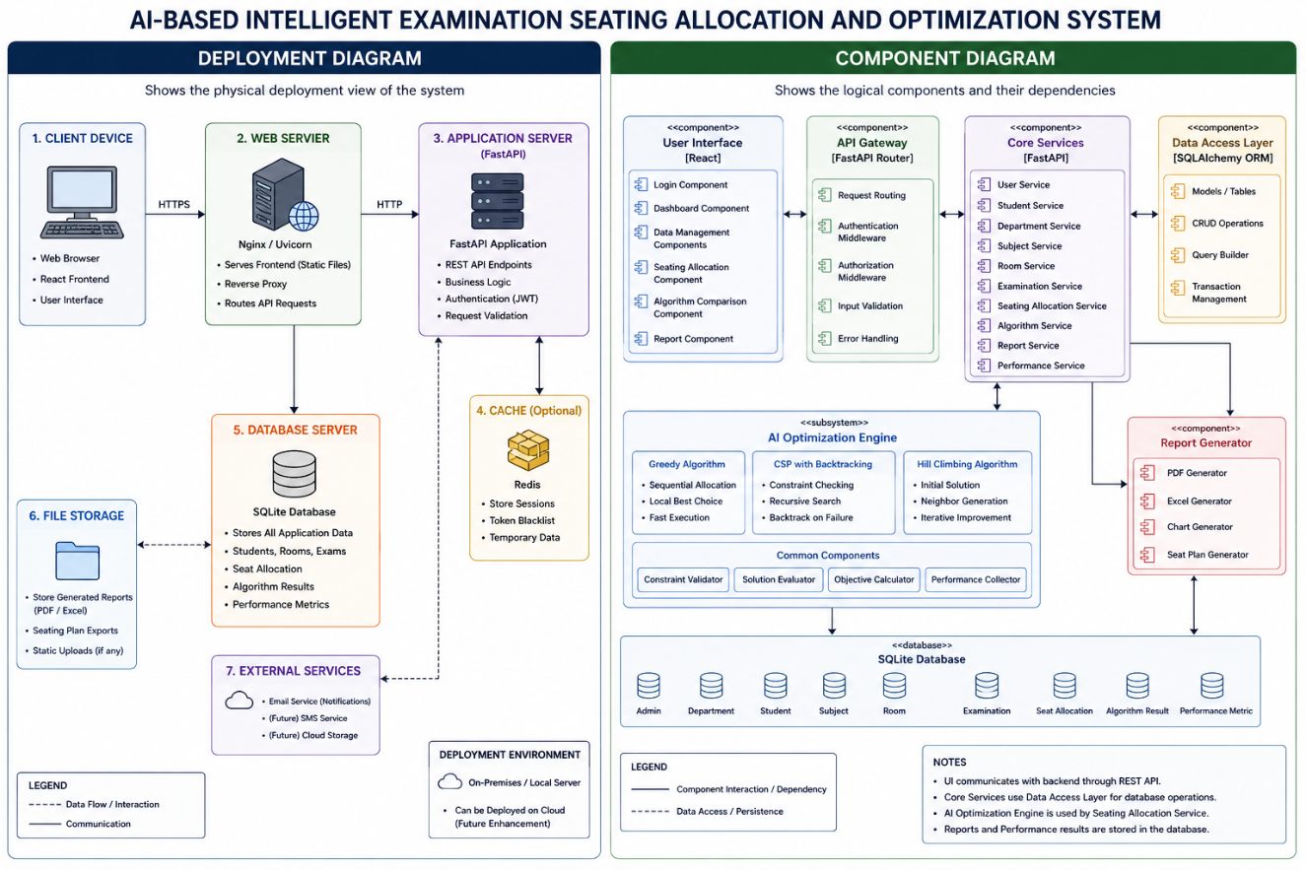
Figure 2.2 — Component/deployment view reconstructed from module interactions

3. Algorithm Identification
Objective: Reverse engineer the AI application to identify the algorithms, data processing steps, and decision-making logic used for examination seating allocation.

3.1 Identification Methodology
Each algorithm is identified by examining (a) its inputs, (b) the sequence of operations it performs, (c) the decision rule it uses to accept or reject a candidate assignment, and (d) its output. This mirrors how an analyst would reverse engineer decision logic from a black-box AI module by observing input/output behavior and any available process description.

3.2 Algorithm 1 — Greedy Algorithm
Classification: Constructive heuristic search (single-pass, no backtracking).
Reverse-engineered decision logic: at each step the algorithm holds a partial seating arrangement and one remaining unseated student. It scans available seats in the currently selected rooms and assigns the student to the first seat that does not violate the immediate hard constraints (seat not already taken, room capacity not exceeded). It never revisits a decision once made.
INPUT: student_list, room_list, constraints
FOR each student in student_list:
seat = find_first_valid_available_seat(room_list, constraints)
IF seat found:
assign(student, seat)
mark seat as taken
ELSE:
record unassigned student
OUTPUT: seating_arrangement, conflict_list
Figure 3.1 — Reconstructed decision logic of the Greedy Algorithm
Aspect | Identification
Data processed | Student list, room/seat availability list, hard constraints
Decision rule | First-fit: accept the first locally valid seat
Termination | All students processed (assigned or flagged unassigned)
Complexity behavior | Linear-time per assignment; fast but not globally optimal

3.3 Algorithm 2 — CSP with Backtracking
Classification: Exhaustive constraint-satisfaction search with chronological backtracking.
Reverse-engineered decision logic: the problem is modeled with students as variables and available seats as their domains. The algorithm selects an unassigned student, tries a candidate seat from that student's domain, and checks it against every hard constraint (uniqueness, capacity, room availability, one-seat-per-student). If a full path of assignments cannot be extended to satisfy all remaining students, the algorithm undoes (backtracks) the most recent assignment and tries the next candidate seat.
INPUT: students (variables), seats (domains), constraints
FUNCTION backtrack(assignment):
IF assignment is complete: RETURN assignment
student = select_unassigned_student()
FOR seat in domain(student):
IF constraints_satisfied(student, seat, assignment):
assignment[student] = seat
result = backtrack(assignment)
IF result != FAILURE: RETURN result
undo assignment[student]
RETURN FAILURE
Figure 3.2 — Reconstructed decision logic of CSP with Backtracking
Aspect | Identification
Variables | Students
Domains | Available seats
Constraints enforced | One student per seat; no duplicate seats; capacity not exceeded; only available rooms used; unique seat numbers; every student assigned
Decision rule | Systematic try-check-backtrack until a fully valid assignment is found or the search space is exhausted
Complexity behavior | Can be computationally expensive as the search space grows; guarantees constraint validity when a solution exists

3.4 Algorithm 3 — Hill Climbing
Classification: Local-search metaheuristic operating on an existing complete solution.
Reverse-engineered decision logic: unlike Greedy and CSP, Hill Climbing does not build a seating arrangement from scratch — it takes an already-valid arrangement (typically the Greedy or CSP output) and repeatedly searches its neighborhood for a modification (e.g., swapping two students' seats) that improves an objective score based on room utilization, empty seats, and conflicts. It accepts a neighbor only if it improves the score, and stops when no neighbor is better.
INPUT: initial_valid_arrangement
current = initial_valid_arrangement
current_score = evaluate(current)
LOOP:
neighbors = generate_neighboring_arrangements(current)
best_neighbor = argmax(evaluate(n) for n in neighbors)
IF evaluate(best_neighbor) > current_score:
current = best_neighbor
current_score = evaluate(best_neighbor)
ELSE:
BREAK // local optimum reached
OUTPUT: current (improved arrangement)
Figure 3.3 — Reconstructed decision logic of Hill Climbing
Aspect | Identification
Input | An existing valid seating arrangement (not raw student data alone)
Objective factors | Room utilization, number of empty seats, number of conflicts, constraint satisfaction
Decision rule | Accept a neighboring arrangement only if its objective score is strictly better
Termination | No improving neighbor exists (local optimum) or iteration limit reached
Complexity behavior | Can become trapped in a local optimum; quality depends on the initial solution supplied to it

3.5 Data Processing Steps Common to All Algorithms
- Load examination-specific student list from the Student and Examination tables.
- Load available rooms and derive seat grid (rows x columns) from the Room table.
- Normalize/prepare the constraint set (hard constraints listed in Section 4 of the design specification).
- Execute the selected algorithm (Greedy, CSP + Backtracking, or Hill Climbing).
- Validate the produced arrangement against all hard constraints.
- Measure performance (execution time, utilization, constraint satisfaction rate, conflict count, memory usage where practical).
- Persist the arrangement to Seat_Allocation and the metrics to Algorithm_Result / Performance_Metric.

3.6 Algorithm Identification Summary
Algorithm | Builds From Scratch? | Guarantees Constraint Validity? | Optimizes an Objective Score?
Greedy | Yes | Only locally, per step | No — first-fit only
CSP + Backtracking | Yes | Yes, when a solution exists | No — feasibility-focused, not optimizing utilization
Hill Climbing | No — refines an existing arrangement | Depends on the input arrangement | Yes — improves utilization/conflicts/empty seats

4. Data Flow and Process Mapping
Objective: Examine the AI application as a distributed client-server system and map its data flow, processing pipeline, and communication between components.

4.1 Distributed System Perspective
Although the system uses a single SQLite database, its client (React SPA) and server (FastAPI) run as separate processes communicating over HTTP, which is the minimum distribution boundary relevant to data-flow mapping: every piece of data that a user enters must cross this boundary as a serialized JSON payload before it can be processed or stored.

4.2 Level 0 Data Flow Diagram

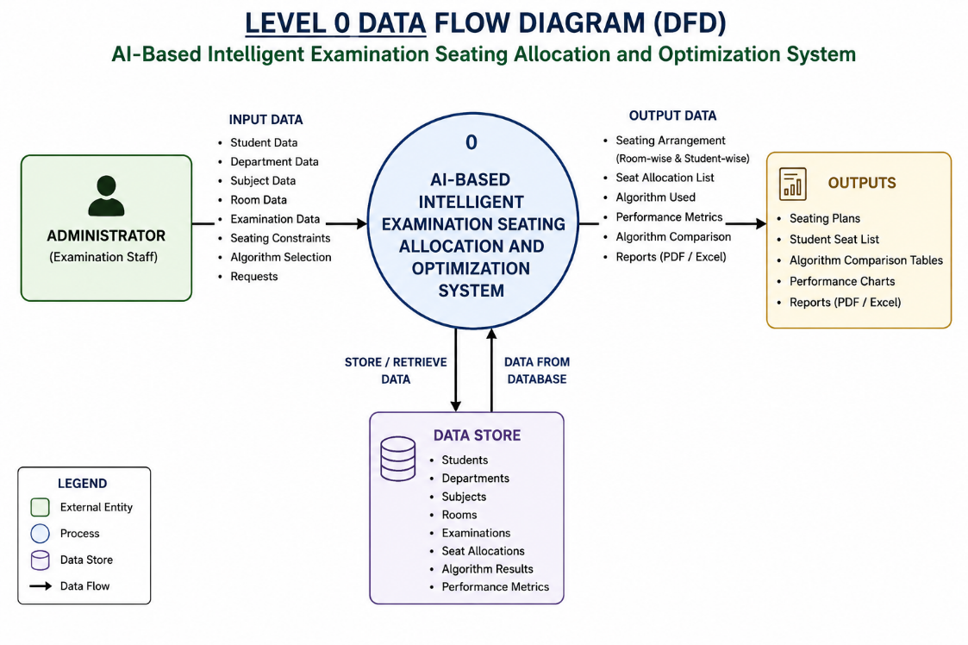
Figure 4.1 — Level 0 DFD (context diagram)

4.3 Level 1 Data Flow Diagram

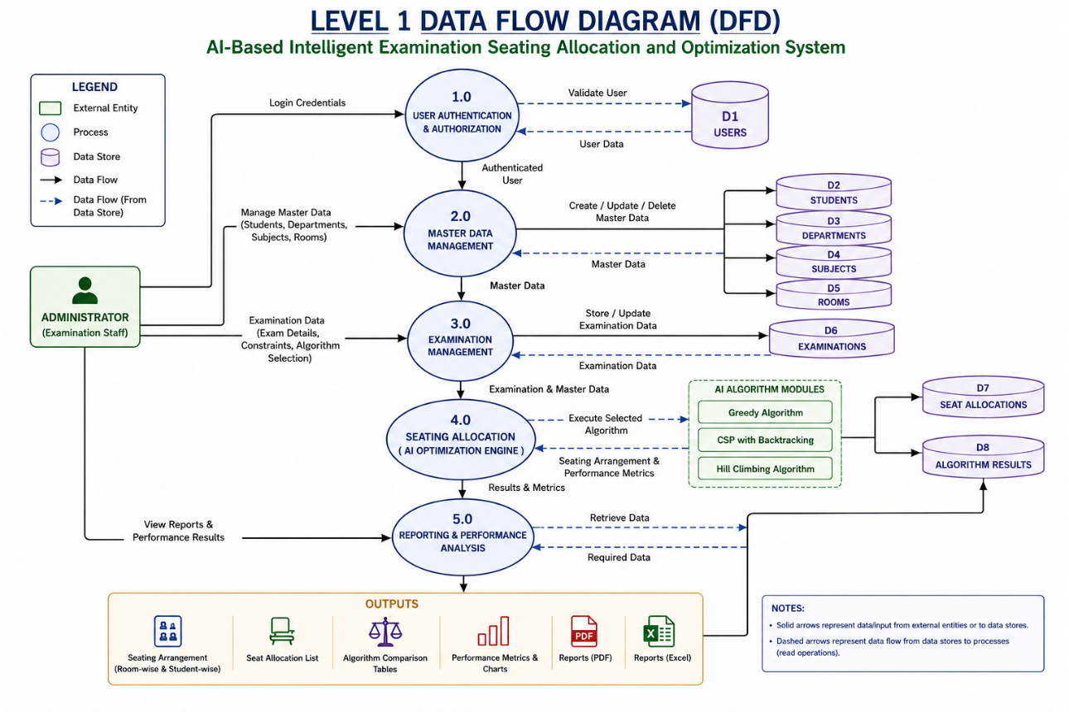
Figure 4.2 — Level 1 DFD (system-level data flow)

4.4 Level 2 Data Flow — AI Processing Pipeline

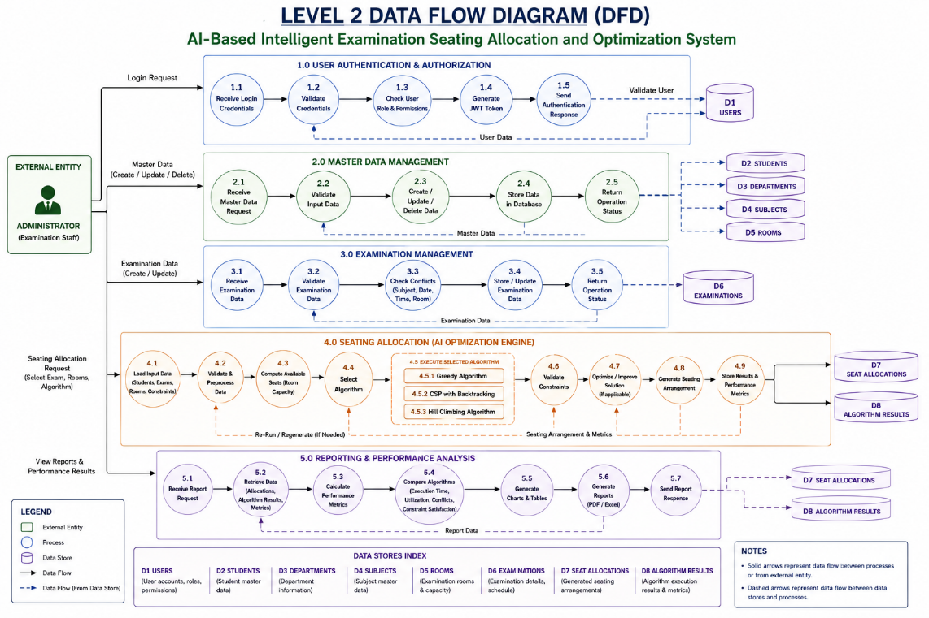
Figure 4.3 — Level 2 DFD: AI processing pipeline

4.5 Component Communication Mapping
Step | From -> To | Protocol / Mechanism | Data Exchanged
1 | Browser -> React App | In-browser rendering | UI state, form inputs
2 | React App -> FastAPI | HTTPS + Axios (JSON, REST) | Auth tokens, CRUD payloads, allocation requests
3 | FastAPI -> SQLite | SQLAlchemy ORM | Entity records (Student, Room, Examination, etc.)
4 | FastAPI -> AI Processing Layer | In-process function/module calls | Student list, room/seat grid, constraint set
5 | AI Processing Layer -> FastAPI | Return values | Seating arrangement, performance metrics
6 | FastAPI -> React App | HTTPS response (JSON) | Seating results, charts data, report file links

4.6 Process Mapping Notes
Mapping this pipeline highlights that the AI Processing Layer sits strictly between the API layer and the database: it never communicates directly with the frontend, and the frontend never communicates directly with the database. This confirms the layered architecture reconstructed in Section 3 and shows that all cross-component communication is mediated by the FastAPI Application Layer, which is the single integration point for authentication, validation, algorithm orchestration, and reporting.

5. Improvement and Redesign
Objective: Based on the reverse-engineered structure of the system, propose enhancements or redesign strategies to improve scalability, efficiency, optimization, maintainability, and dynamic reallocation capability.

5.1 Scalability
- Introduce database indexing on frequently queried columns (roll number, examination ID, room ID) as the ~200-student test dataset grows toward institution-wide scale.
- Migrate from SQLite to a client-server RDBMS (e.g., PostgreSQL) if the system is deployed for multi-department, concurrent-admin use, since SQLite's single-writer model can become a bottleneck under concurrent seating-generation requests.
- Partition seating generation by examination session so that large multi-room, multi-department examinations can be processed in parallel batches rather than as one monolithic request.

5.2 Efficiency
- Cache room/seat-grid data during a single allocation run instead of re-querying the database for every candidate assignment, reducing redundant I/O in the Greedy and CSP algorithms.
- For CSP with Backtracking, apply constraint propagation (e.g., forward checking) to prune the search space earlier, reducing the computational cost identified as a limitation in Section 3.3.
- Limit Hill Climbing's neighbor generation to a bounded, targeted subset (e.g., students in under-utilized vs over-utilized rooms) rather than the full neighborhood, to reduce per-iteration cost.

5.3 Optimization
- Extend the Hill Climbing objective function with configurable weights per factor (utilization, empty seats, conflicts) so administrators can tune optimization priorities per examination.
- Use the Greedy or CSP output as a documented, consistent starting point for Hill Climbing, since Section 3.4 identifies that Hill Climbing's result quality depends on its initial solution.
- Introduce a restart or simulated-annealing-style variation as a future enhancement to reduce the risk of Hill Climbing settling in a local optimum, without removing the existing simpler Hill Climbing option.

5.4 Maintainability
- Keep the three algorithms behind a common interface (e.g., a shared function signature accepting students/rooms/constraints and returning arrangement + metrics) so a new algorithm can be added without modifying the API or frontend layers.
- Separate constraint-definition logic from algorithm logic so hard constraints (Section 4 of the specification) can be updated centrally and automatically apply to all three algorithms.
- Add automated tests around constraint validation (duplicate seats, capacity violations) so that future changes to any algorithm cannot silently reintroduce conflicts.

5.5 Dynamic Reallocation
- The current design (Section 25 of the specification) already lists dynamic real-time reallocation as a future enhancement; this reverse-engineering analysis confirms it is architecturally feasible because the AI Processing Layer is stateless and already accepts arbitrary student/room/constraint input, so a partial re-run (only unseated or affected students) could be added without redesigning the layer.
- A recommended redesign path is to expose a narrower 'reallocate subset' endpoint that reuses the existing Hill Climbing neighbor-generation logic, but restricted to only the seats affected by a last-minute change (e.g., a room becoming unavailable).

5.6 Summary of Proposed Enhancements
Improvement Area | Proposed Change | Expected Benefit
Scalability | RDBMS migration path + indexing + session partitioning | Supports institution-wide, concurrent use
Efficiency | Caching, constraint propagation, bounded neighbor search | Faster execution time metric
Optimization | Weighted objective function, documented HC starting point | Better room utilization / fewer conflicts
Maintainability | Common algorithm interface, centralized constraints, tests | Easier to extend with new algorithms safely
Dynamic Reallocation | Partial-reallocation endpoint reusing Hill Climbing logic | Handles last-minute changes without full re-generation

These proposals are consistent with, and extend, the Limitations (Section 24) and Future Enhancements (Section 25) already identified in the original solution document; no new technologies outside the specified stack are assumed, and no performance figures are asserted — all quantitative claims of improvement would need to be validated experimentally and are labeled accordingly as "to be measured."

6. Conclusion
This reverse-engineering analysis decomposed the AI-Based Intelligent Examination Seating Allocation and Optimization System into its constituent presentation, application, AI-processing and data layers; reconstructed its architecture and module interactions from a black-box perspective; identified the decision logic of the Greedy, CSP with Backtracking, and Hill Climbing algorithms; mapped the system's data flow across its distributed client-server boundary; and proposed concrete, specification-consistent improvements for scalability, efficiency, optimization, maintainability, and dynamic reallocation. Together with the original solution document, this analysis satisfies the reverse-engineering component required for the capstone submission while remaining strictly within the technologies, algorithms, and data defined in the project specification.

